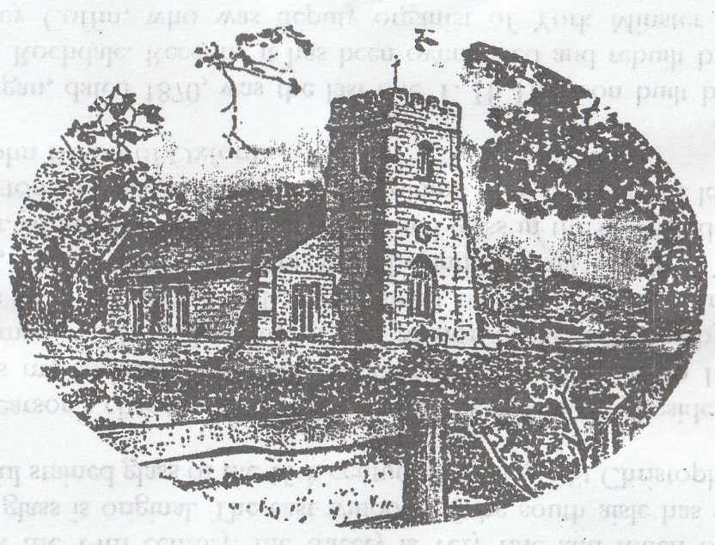
A guide to
All Saints’ Church Settrington
with notes on
The Manor of Settrington
The parish church of All Saints’ Settrington dates from the 12th century with later additions and alterations.
The south door has rather unusual late Norman chevron ornament on Tuscan pillars which may be part of the 1823 restoration. The Norman work is so individual that perhaps it was made up from stones brought from Kirkham Priory or Old Malton by some restorer with antiquarian leanings.
The font is also late 12th century. The three eastern bays of the arcade are very early 13th century and have flat-leafed capitals. The western bays were added when the tower was built at the end of the 14th century.
The tower is very fine and originally had a stone spire. The pierced battlements and the band of wavy tracery suggest that it may have been by the same master mason as the towers at Wintringham and Huggate. The heraldry belongs to the Bigod family, who were the Lords of the Manor of Settrington from the 13th to 16th century. The west doorway is nicely moulded and there is a particularly good Perpendicular window above it and, just to the left, in the angle of a buttress is a little, carved crouching figure of a man.
Much of the exterior stonework was reworked or replaced at a restoration in 1823, when the south porch was demolished and its heraldry was reset in the south wall of the nave. J L Pearson, the architect of Truro Cathedral, did a design for restoration in the chancel in 1861, and provided a modified design which was executed in 1867-8.
The west window has stained glass in memory of Archdeacon Todd, Rector of Settrington, who died in 1845, some of the earliest Victorian stained glass hereabouts.
Beside the door of the tower staircase is the Royal Arms of George II, dated 1734. There are amusing carvings at the sides of the tall tower arch.
On the baptistry wall is a board listing the Rectors of Settrington from 1248. Of particular interest are the four ‘intruded priests’ of the Commonwealth period. They follow John Carter, Rector in1641 who, with his wife and children, was forcibly ejected in 1644. He was reinstated in 1660 and died in 1666. There is a brass to him on the north wall of the chancel.
The plaster ceilings, flat in the aisles, and barrel vaulted in the nave, are an unusual and attractive feature. The south chapel was refurnished in 1951 when the oak pews and kneeler (the work of Thompson of Kilburn) and the alter furniture and piscina were given by the late Lord Buckton in memory of his wife Elizabeth. The designs for the chapel were by the late Mr George Pace, the Church architect at the time.
The windows of the north and south aisles are in the Perpendicular style of the 14th century: the tracery is vet fine and much of the crown glass is original. The east window of the south aisle has some beautiful stained glass of the 15th century including a St. Christopher.
J L Pearson’s chancel is raised on several steps and has, besides Mr Carter’s memorial, several fine monuments especially one to Henry Masterman, died 1769, Lord of the Manor of Settrington, by the Fishers of York. Other tablets are signed by W G Nicholl and R Brown, both London sculptors, Wandy and Michael Taylor of York, and Mr Monkman of Malton. The stained glass in the east window is by Clayton and Bell, c.1868. The two volume 1716 bible on the lectern is by John Basket of Oxford.
The organ, dated 1870, was the last one T H Harrison built before leaving Rochdale. Recently it has been overhauled and rebuilt by Mr Geoffrey Coffin, who was deputy organist of York Minster from 1971-5.

The Manor of Settrington
The advowson of All Saints Church is now held by Lord Brownlow to whom it passed from Lord Chancellor Egerton who, in turn received it as a gift from James 1, Before that it was held by the Bigod family until 1537 when Sir Francis Bigod was executed for high treason for his part in the Pilgrimage of Grace.
Sir Francis’s Elizabethan house stood to the east 0f the church until the 18th century when the Masterman family pulled that house down and in 1793 completed the present Settrington House. The house, which formerly consisted of a main block of three storeys and two pedimented pavilions, was gutted by fire in 1963. The re-building was the work of the late Lord Buckton and of Mr Francis Johnson; the house is now lived in by Kenelm Storey, Lord Buckton’s grandson.
The stables and riding school were built in 1791.
Settrington village is largely composed of identical stone estate cottages built circa 1800 by Sir Mark Sykes, Bt., and his wife, formerly Henrietta Masterman, who had become the sole heiress of Settrington estate. A survey of the manor of Settrington done for Queen Elizabeth 1 in 1590 shows that the outline of the village has changed little – though during the rebuilding of 1800 the cottages beside the Beck were moved back to higher ground and those near the church demolished.
At the time of Sir Francis Bigod’s attainder, the Manor of Settrington was seized by the Crown and given to the Countess of Lennox, mother of Lord Darnley who was born in Settrington House. One of Lord Darnley’s descendants was created Baron Settrington by James1, but the title died out and was then revived by Charles 11 who conferred it, with the family name of Lennox and the Dukedom of Richmond (now Richmond and Gordon), on his illegitimate son by Louise de Keronalle.
June 1980

